**Indira Gandhi Delhi Technical University for Women**

**(Established by Govt. of Delhi vide Act 09 of 2012)**

**(Formerly Indira Gandhi Institute of Technology)**

**Kashmere Gate, Delhi - 110006**



**LABORATORY FILE**

**for**

**Web Technologies**

**MCA 207**

**Submitted by:**

**Submitted to:**

Ms. Ankita Singh Roopal Mittal

MCA, 3rd Sem

02004092019

**Date: 13-08-2020**

**LAB 2 WORK**

**Ques 2: Develop a Student Login form with Login Id, Password, submit, reset button and also allow to have forgot password link.**

**HTML Code:**

<!DOCTYPE html>

<html lang="en">

<head>

<title> Login Page </title>

<style>

h1 {

color: white;

}

button {

background-color: #33FF38 ;

}

.container {

padding: 40px;

width: 300px;

background-color: #F9FF33 ;

}

</style>

</head>

<body bgcolor="#0F044F">

<center> <h1><u> Student Login Form </u></h1>

<form >

<div class="container">

<label>Login ID : </label>

<input type="text" placeholder="Enter Username" name="username" required>

<br><br>

<label>Password : </label>

<input type="password" placeholder="Enter Password" name="password" required>

<br>

<input type="checkbox" checked="checked"> Remember me

<br><br>

<button type="submit">Submit</button>

<button type="button" class="cancelbtn"> Reset </button>

<br><a href=" "> Forgot password? </a>

</div>

</form>

</center>

</body>

</html>

**OUTPUT Webpage:**

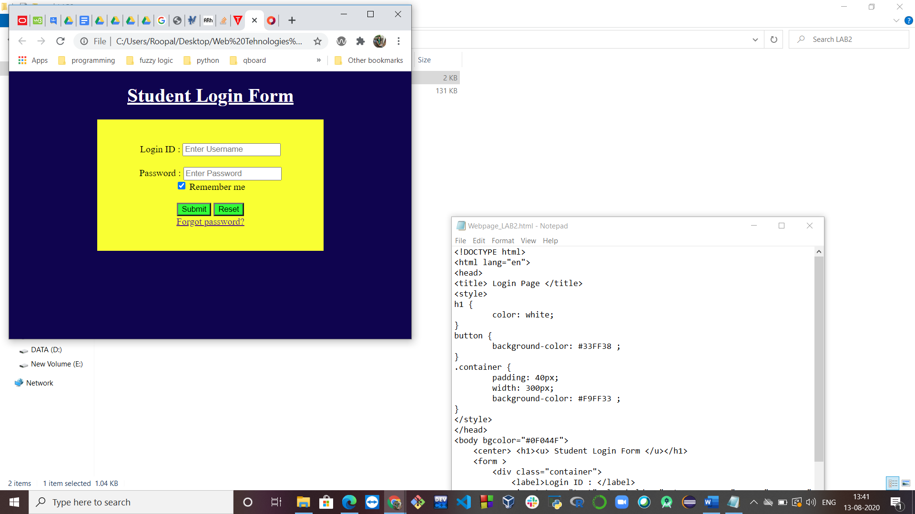

**Ques 3: Develop a student (Name, Roll No.) registration form by using HTML forms, textfield, button, checkbox, radiobutton, hidden button and textarea.**

**HTML Code:**

<!DOCTYPE html>

<html lang='en'>

<head>

<style>

.container {

padding: 50px;

align: center;

background-color: lightblue;

}

input[type=text], input[type=password], textarea {

width: 100%;

padding: 15px;

margin: 5px 0 22px 0;

display: inline-block;

background: #f1f1f1;

}

input[type=text]:focus, input[type=password]:focus {

background-color: pink;

outline: none;

}

div {

padding: 10px 0;

}

hr {

border: 1px solid #f1f1f1;

margin-bottom: 25px;

}

.registerbtn {

background-color: #4CAF50;

color: white;

padding: 16px 20px;

width: 100%;

}

<title>Student Registeration </title>

</style>

</head>

<body bgcolor="black" text="black">

<form>

<div class="container">

<center> <font color= "black"> <h1> Student Registeration Form <font></h1> </center>

<hr>

<label> Firstname </label>

<input type="text" name="firstname" placeholder= "Firstname" size="15" required />

<label> Middlename: </label>

<input type="text" name="middlename" placeholder="Middlename" size="15" required />

<label> Lastname: </label>

<input type="text" name="lastname" placeholder="Lastname" size="15"required />

<div>

<label>

Course :

</label>

<select>

<option value="Course">Course</option>

<option value="BCA">BCA</option>

<option value="BBA">BBA</option>

<option value="B.Tech">B.Tech</option>

<option value="MBA">MBA</option>

<option value="MCA">MCA</option>

<option value="M.Tech">M.Tech</option>

</select>

</div>

<div>

<label>

Gender :

</label><br>

<input type="radio" value="Male" name="gender" checked > Male

<input type="radio" value="Female" name="gender"> Female

<input type="radio" value="Other" name="gender"> Other

</div>

<label>

Phone :

</label>

<input type="text" name="country code" placeholder="Country Code" value="+91" size="2"/>

<input type="text" name="phone" placeholder="phone no." size="10"/ required>

Current Address :

<textarea cols="80" rows="5" placeholder="Current Address" value="address" required>

</textarea>

<label for="email"><b>Email</b></label>

<input type="text" placeholder="Enter Email" name="email" required>

<label for="psw"><b>Password</b></label>

<input type="password" placeholder="Enter Password" name="psw" required>

<label for="psw-repeat"><b>Re-type Password</b></label>

<input type="password" placeholder="Retype Password" name="psw-repeat" required>

<button type="submit" class="registerbtn">Register</button>

</form>

</body>

</html>

**OUTPUT Webpage:**

